PHASE4: DEVELOPMENT PART 2
NAME: S.Aravind
REG.NO: 822721104301
EMAIL ID: aravindcrazzaravind@gmail.com
In this phase, we have created e-commerce platform by implementing user authentication, shopping cart and checkout functionality.
USER REGISTRATION AND AUTHENTICATION:
HTML CODE:
<!DOCTYPE html>
<html lang="en">
<head>
<meta charset="UTF-8">
<meta http-equiv="X-UA-Compatible" content="IE=edge">
<meta name="viewport" content="width=device-width,initial-scale=1.0">
<title>LOGIN FORM</title>
<link rel="stylesheet" href="login.css">
<link href='https://unpkg.com/boxicons@2.1.4/css/boxicons.min.css' rel='stylesheet'>
</head>
<body>
<header>
<h2 class="logo">CRAFTING CURIOSITIES</h2>
<nav class="navigation">
<a href="#">Home</a>
<a href="#">About</a>
<a href="#">Services</a>
<a href="#">Contact</a>
<button class="btnLogin-popup">Login</button>
</nav>
</header>
<div class="wrapper">
<form action="">
<h1>Login</h1>
<div class="input-box">
<input type="text" placeholder="Username" required>
<i class='bx bxs-user'></i>
</div>
<div class="input-box">
<input type="password"
placeholder="Password" required>
<i class='bx bxs-lock-alt'></i>
</div>
<div class="remember-forgot">
<label><input type="checkbox"> Remember me</label>
<a href="#">Forgot password?</a>
</div>
<button type="submit" class="btn">Login</button>
<div class="register-link">
<p>Don't have an account? <a href="#">Register</a></p>
</div>
</form>
</div>
</body>
</html>

CSS CODE:
@import url("https://fonts.googleapis.com/css2?family=Poppins:wght@300;400;500;600;700;800;900&display=swap");
*{
margin: 0;
padding: 0;
box-sizing: border-box;
font-family: "Poppins",sans-serif;
}
header{
position: fixed;
top: 0;
left: 0;
width: 100%;
padding: 20px 100px;
background: transparent;
display: flex;
justify-content: space-between;
align-items: center;
z-index: 99;
}
.logo{
font-size: 2em;
color: #fff;
user-select: none;
}
.navigation a{
position: relative;
font-size: 1.1em;
color: #fff;
text-decoration: none;
font-weight: 500;
margin-left: 40px;
}
.navigation a::after{
content: '';
position: absolute;
left: 0;
bottom: -6px;
width: 100%;
height: 3px;
background: #fff;
border-radius: 5px;
transform-origin: right;
transform: scaleX(0);
transition: transform.5s;
}
.navigation a:hover::after{
transform-origin: left;
transform: scaleX(1);
}
.navigation .btnLogin-popup{
width: 130px;
height: 50px;
background:transparent;
border:2px solid #fff;
outline: none;
border-radius: 6px;
cursor: pointer;
font-size:1.1em;
color: #fff;
font-weight: 500;
margin-left: 40px;
}
body{
display: flex;
justify-content: center;
align-items: center;
min-height: 100vh;
background: url('Fut.jpg') no-repeat;
background-size: cover;
}
.wrapper{
width: 420px;
background: transparent;
backdrop-filter: blur(20px);
box-shadow: 0 0 10px rgba(0,0,0, .2);
color:#fff;
border-radius: 10px;
padding: 30px 40px;
}
.wrapper h1{
font-size: 36px;
text-align: center;
}
.wrapper .input-box{
position: relative;
width: 100%;
height: 50px;
margin: 30px 0;
}
.input-box input{
width: 100%;
height: 100%;
background:transparent;
border:none;
outline: none;
border:2px solid rgba(255,255,255, .2);
border-radius: 40px;
font-size: 16px;
color: #fff;
padding: 20px 45px 20px 20px;
}
.input-box input::placeholder{
color: #fff;
}
.input-box i{
position: absolute;
right: 20px;
top:50%;
transform: translateY(-50%);
font-size: 20px;
}
.wrapper .remember-forgot{
display: flex;
justify-content: space-between;
font-size: 14.5px;
margin: -15px 0 15px;
}
.remember-forgot label input{
accent-color: #fff;
text-decoration: none;
}
.remember-forgot a{
color: #fff;
text-decoration: none;
}
.remember-forgot a:hover{
text-decoration: underline;
}
.wrapper .btn{
width: 100%;
height: 45px;
background: #fff;
border: none;
outline: none;
border-radius: 40px;
box-shadow: 0 0 10px rgba(0,0,0, .1);
cursor: pointer;
font-size: 16px;
color: #333;
font-weight: 600;
}
.wrapper.register-link{
font-size: 14.5px;
text-align: center;
margin-top: 20px 0 15px;
}
.register-link p a{
color: #fff;
text-decoration: none;
font-weight: 600;
}
.register-link p a:hover{
text-decoration: underline;
}

OUTPUT:
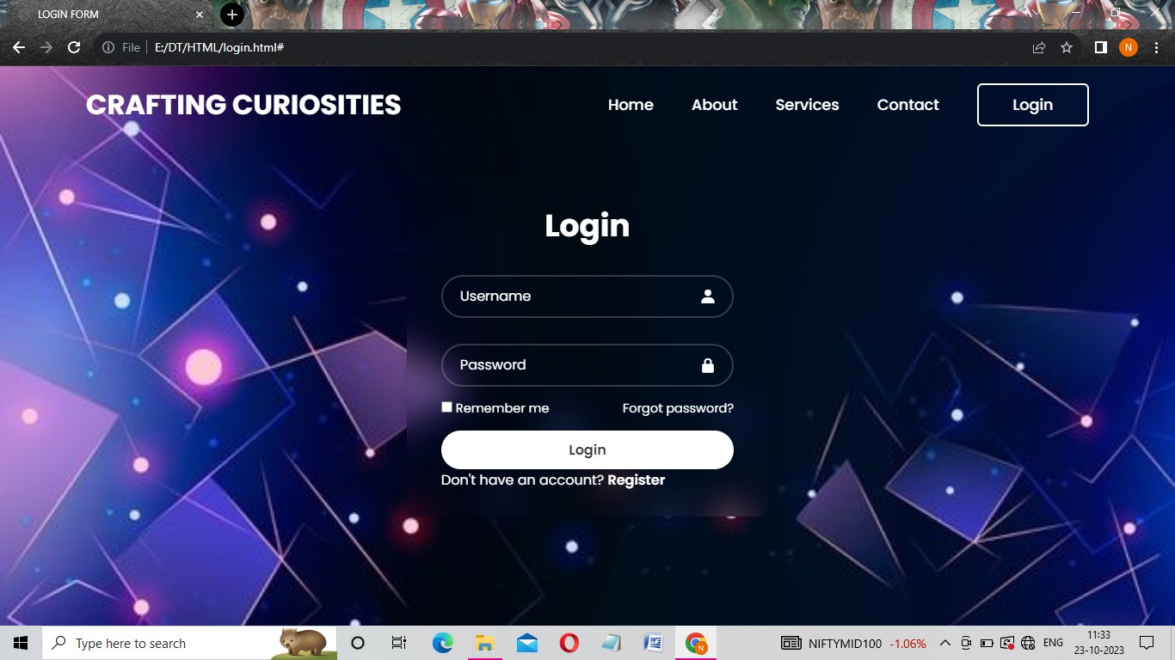

SHOPPING CART:
HTML CODE:
<!DOCTYPE html>
<html>
<head>
<title>Shopping Cart</title>
<style type="text/css">
body {
font-family: Arial, sans-serif;
background-image: url(Fut.jpg);
background-size:contain;
margin: 0;
padding: 0;
}
header {
background-color: #333;
color: #fff;
padding: 10px;
text-align: center;
}
h1 {
margin: 0;
font-size: 36px;
}
main {
background-color: #fff;
border-radius: 5px;
box-shadow: 0px 0px 10px rgba(0,0,0,0.2);
margin: 20px auto;
padding: 20px;
width: 80%;
}
table {
border-collapse: collapse;
width: 100%;
}
th, td {
text-align: left;
padding: 8px;
}
tr:nth-child(even) {
background-color: #f2f2f2
}
tr:hover {
background-color: #ddd
}
th {
background-color: #333;
color: white;
}
.btn {
background-color: #333;
border-radius: 5px;
color: white;
display: block;
margin-top: 20px;
padding: 10px 20px;
text-align: center;
text-decoration: none;
}
.btn:hover {
background-color: #555
}
.btn-checkout {
background-color: green
}
.btn-clear {
background-color: red
}
.cart-total {
font-size: 24px
}
.cart-item-remove {
color:red
}
.cart-item-remove:hover {
cursor:pointer
}
</style>
</head>
<body>
<header>
<h1>Shopping Cart</h1>
</header>
<main>
<table>
<thead>
<tr>
<th>Product</th>
<th>Price</th>
<th>Quantity</th>
<th>Total</th>
<th></th>
</tr>
</thead>
<tbody id="cart-items">
<tr class="cart-item">
<td><img src="Jute.jpeg" height="200" width="200"></td>
<td>₹110.00</td>
<td><input type="number" value="1" min="1"></td>
<td>₹110.00</td>
<td><span class="cart-item-remove">X</span></td>
</tr>
<tr class="cart-item">
<td><img src="Bag.jpeg" height="200" width="200"></td>
<td>₹150.00</td>
<td><input type="number" value="1" min="1"></td>
<td>₹150.00</td>
<td><span class="cart-item-remove">X</span></td>
</tr>
</tbody>
</table>

<div class="cart-total">Total :₹260.00</div>

<a href="#" class="btn btn-clear">Clear Cart</a>

<a href="#" class="btn btn-checkout">Checkout</a>

</main>

<script type="text/javascript">
let cartItems = document.querySelectorAll('.cart-item');
let cartTotal = document.querySelector('.cart-total');
let btnClear = document.querySelector('.btn-clear');
let btnCheckout = document.querySelector('.btn-checkout');

function updateCartTotal() {
let total = 0;

cartItems.forEach(function(item) {
let price = item.querySelector('td:nth-child(2)').textContent.replace('₹', '');
let quantity = item.querySelector('input').value;

total += price * quantity;

item.querySelector('td:nth-child(4)').textContent = '₹' + (price * quantity).toFixed(2);
});

cartTotal.textContent = 'Total : ₹' + total.toFixed(2);
}

function removeCartItem() {
this.closest('.cart-item').remove();
updateCartTotal();
}

cartItems.forEach(function(item) {
item.querySelector('.cart-item-remove').addEventListener('click', removeCartItem);
item.querySelector('input').addEventListener('change', updateCartTotal);
});

btnClear.addEventListener('click', function() {
cartItems.forEach(function(item) { item.remove(); });
updateCartTotal();
});

btnCheckout.addEventListener('click', function() { alert('Checkout clicked!'); });
</script>

</body>
</html>

OUTPUT:
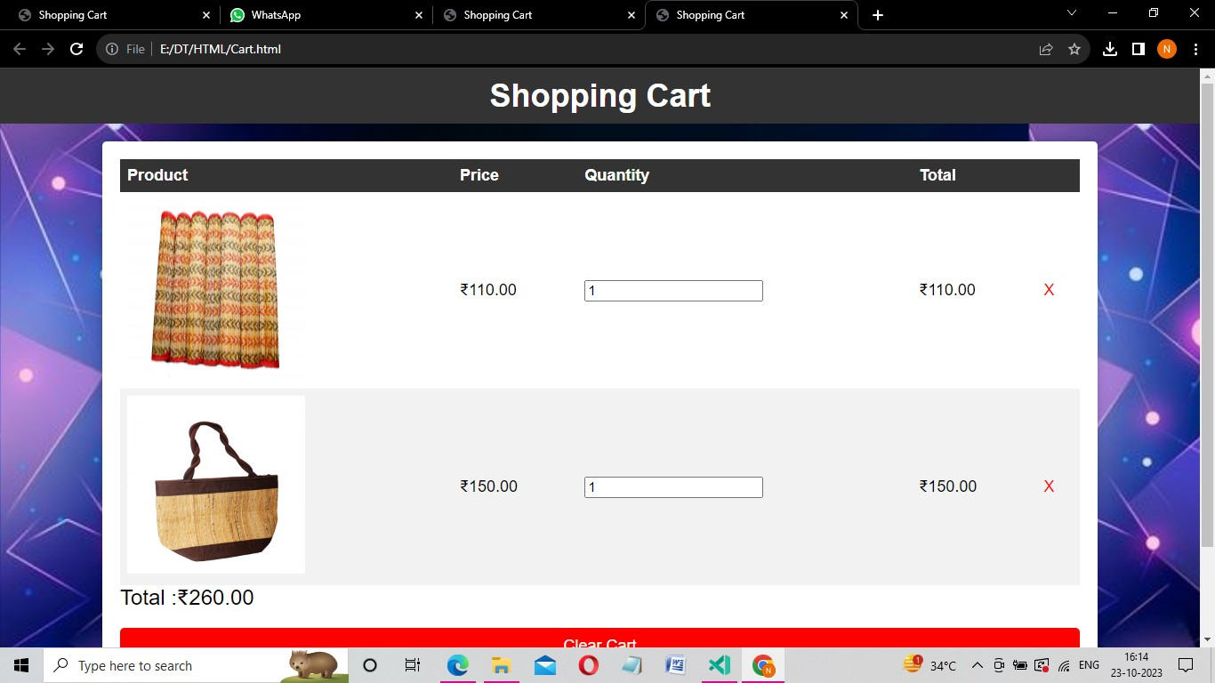
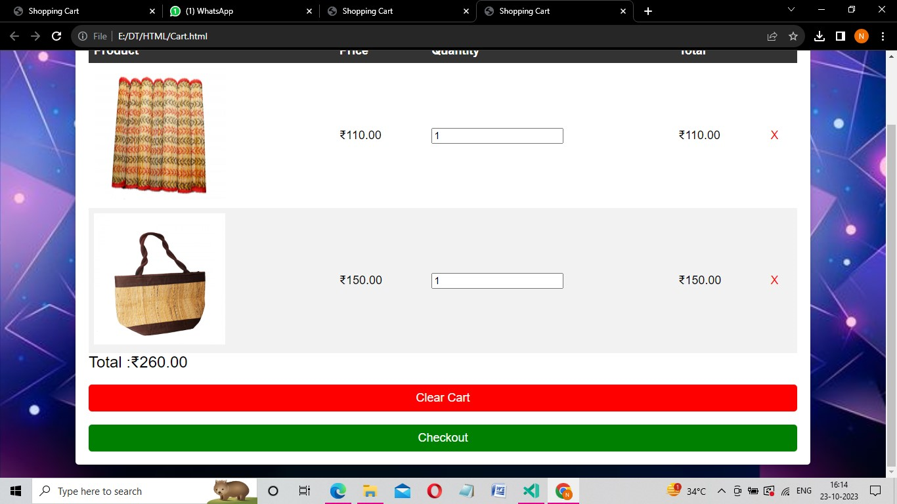

CHECKOUT PROCESS:
<!DOCTYPE html>
<html>
<head>
<title>Artisan Checkout</title>
<link rel="stylesheet" type="text/css" href="checkout.css">
</head>
<body>
<div class="container">
<h1>Checkout</h1>
<form action="process_order.php" method="post">
<!-- Customer Information -->
<h2>Customer Information</h2>
<div class="form-group">
<label for="name">Name:</label>
<input type="text" id="name" name="name" required>
</div>
<div class="form-group">
<label for="email">Email:</label>
<input type="email" id="email" name="email" required>
</div>

<!-- Shipping Information -->
<h2>Shipping Information</h2>
<div class="form-group">
<label for="address">Address:</label>
<input type="text" id="address" name="address" required>
</div>
<div class="form-group">
<label for="city">City:</label>
<input type="text" id="city" name="city" required>
</div>
<div class="form-group">
<label for="zip">ZIP Code:</label>
<input type="text" id="zip" name="zip" required>
</div>

<!-- Product Information (example) -->
<h2>Product Details</h2>
<p>Product: Oxidised Silver Necklace</p>
<p>Price: 599</p>

<!-- Payment Information -->
<h2>Payment Information</h2>
<div class="form-group">
<label for="card">Credit Card:</label>
<input type="text" id="card" name="card" required>
</div>
<div class="form-group">
<label for="exp">Expiration Date:</label>
<input type="text" id="exp" name="exp" required>
</div>
<div class="form-group">
<label for="cvv">CVV:</label>
<input type="text" id="cvv" name="cvv" required>
</div>

<!-- Submit Button -->
<div class="form-group">
<input type="submit" value="Place Order">
</div>
</form>
</div>
</body>
</html>

CSS CODE:
body {
font-family: Arial, sans-serif;
background: url('check.jpeg') no-repeat;
background-size: cover;
}

.container {
max-width: 600px;
margin: 0 auto;
padding: 20px;
border: 1px solid #ccc;
background-color: #f9f9f9;
}

h1 {
text-align: center;
}

form {
margin-top: 20px;
}

.form-group {
margin: 10px 0;
}

label {
display: block;
}

input[type="text"],
input[type="email"]

OUTPUT:
